## Merchant

Demo date: Oct 22, 2024  
Custom demo date: Oct 30, 2024

MSA Signature Date: Oct 30, 2024  
Onboarding Kick Off Date: Nov 11, 2024  
Go Live Date:

GTM POC: Daniel  
Implementation POC: Dani

ERP: QBO

Tax Integration: No Tax

### 

### Key people at Merchant

* Head of Business Ops (does it all) - John Pisano - john@goodship.io

### 

| Notes Sections [Ops International Team to Ignore] *(AE/ Implementation to fill)*   * Info on how merchant bills   + Mix of monthly, quarterly, annually ~25 clients, pure SaaS billing   Is there any important merchant relationship information?  1) What is the merchant temperament?  -Startup guy who wears all finance / ops hats. Lives in Jacksonville and remote company. About Daniel’s age and is almost as friendly as Daniel (he’s very nice). 2) Is there a key POC: CEO has final approval but is not a blocker (trusts John to make decisions, John is a signer) 3) What are the Tabs features that the key POC cares about?  Billing and invoice scheduling. Revenue reporting. |
| --- |

### 

### Company summary *(AE to fill)*

[GoodShip](https://www.goodship.io/) is the first all-in-one platform for freight orchestration and procurement. Our innovative software helps shippers optimize their freight spend and service outcomes, while enhancing collaboration among internal teams and carrier partners.

Our platform brings together disparate data sources (e.g., tender data, real-time location, contract awards, market benchmarks) to offer shippers a comprehensive view of their transportation network. With our advanced recommendation engine, users can identify the highest impact opportunities to save money, improve on-time service, and reduce reliance on the spot market.

More than just analytics, GoodShip provides actionable insights directly within the platform. Transportation teams can easily take corrective actions, such as renegotiating contract rates, initiating performance alerts, or running off-cycle and network-wide bids with best-in-class, purpose-built procurement tools. These capabilities give shippers the agility and resilience to optimize their networks amidst volatile market conditions and shifting carrier performance.

Goals (North star)  
*(AE/ Implementation to fill)*

What is the merchant's goal? What pain are we solving? Why are they buying Tabs?

* Automating invoicing/billing and managing contracts are the biggest pain points. Using this to avoid hiring a finance person to handle billing / rev reporting. QBO users who were thinking about moving to NetSuite. They use Pilot as well for fractional accounting.

Is there an opt out clause? If so, what is the merchant looking for so they do not exercise it?

* No

### Billing model*(AE/ Implementation to fill)*

* Are there unique things about the customer creation process for this merchant?

Monthly, quarterly, biannual, and annual billing. Pure SaaS. Do have some large buyers with AP portal. Do have some escalator clauses

* Information on how merchant bills

Flat monthly

* How contract is broken up

N/A

* One off things to know about the merchant

N/A

### 

### Contract Processing Steps

1. **Steps to process**
   1. **If the contract only shows one year** *(see an example for Coca-Cola below) Refer to this* [*garage link*](https://garage.tabsplatform.com/prod/contracts/9c3ee000-2204-436f-8cf9-e00af116cba3/terms/revenue) *to see an example of processing*
      1. Refer to the “services fee” section
      2. Make 1 revenue schedule. Ensure the total price matches “the discounted fee”
      3. Do not process the “subscription list price”
      4. Only process the discounted fee schedule
      5. Service term- refer to the contract for dates and length of service
      6. Payment terms vary from customer to customer, please read the “payment terms” section to find net terms
      7. Default Item Name: GoodShip Orchestration & Procurement
      8. Item Description: enter “Year 1”
      9. Integration Item: Platform Access
      10. 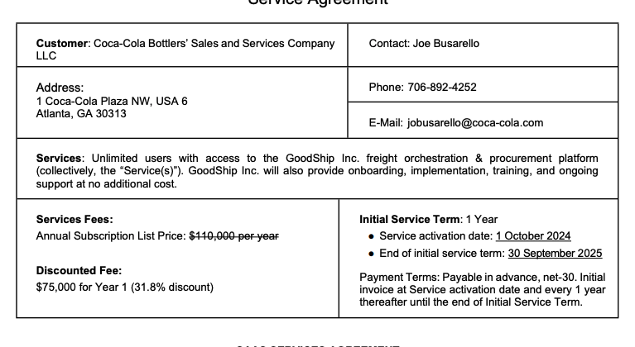
   2. ***If the contract shows more than 1 year with different prices for each year*** *(see an example for James Hardie Building Products below) Refer to this* [*garage link*](https://garage.tabsplatform.com/prod/contracts/7c0368b3-67ae-4b35-b3f0-c7e8d485a4d2/terms/key) *to see an example of processing*
      1. Refer to the “services fee” section
      2. Make a revenue schedule for each year listed (for example: if it shows 3 years, you would make 3 rev schedules
      3. Do not process the “subscription list price”
      4. Only process the discounted fee schedule
      5. Service term- refer to the contract for dates and length of service
      6. Payment terms vary from customer to customer, please read the “payment terms” section to find net terms
      7. Default Item Name: GoodShip Orchestration & Procurement
      8. Item Description: Enter Year # (for example, if the line item is for year 3, we would enter “Year 3”)
      9. Integration Item: Platform Access

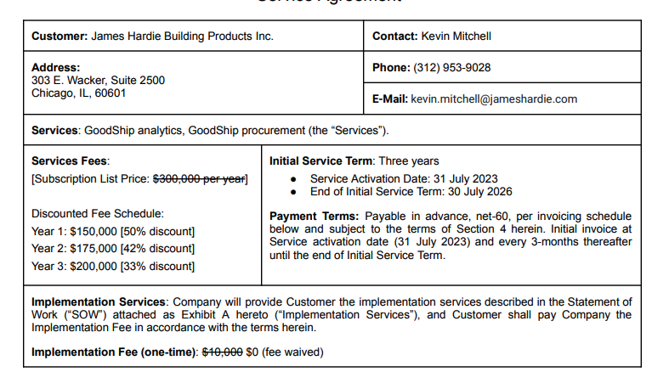

* 1. **If the contract shows more than 1 year with the same prices for each year** (see example for Univar Solutions below) Refer to this [garage link](https://garage.tabsplatform.com/prod/contracts/1ffdcd97-a6f8-4378-96b4-9014df758f07/terms/revenue) to see an example of processing
     1. Refer to the “services fee” section
     2. Make one revenue schedule
     3. Do not process the “subscription list price”
     4. Only process the discounted fee schedule
     5. Service term- refer to the contract for dates and length of service
     6. Please note some are monthly payments or quarterly payments, you will need to change periods according to how long their contract is
     7. Payment terms vary from customer to customer, please read the “payment terms” section to find net terms
     8. Item Name: GoodShip Orchestration & Procurement
     9. Item Description: Can leave blank
     10. Integration Item: Platform Access

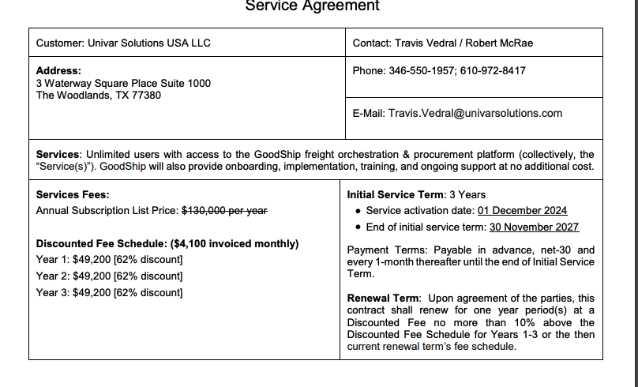

1. **Anything to ignore in contracts?**
   1. Annual Subscription Price
2. **Specifics processing things merchant has requested that may differ by contract (e.g. always back-date invoice date to final day of the month)**
   1. Contract length and payment terms will differ by contract
3. **Default Service Term**
   1. Refer to contract
4. **Default Net Payment Terms** 
   1. Refer to contract
   2. If you see PR#- it means Net# (example: PR30 = Net30)
   3. Net Payment Terms- please check each contract since this changes for each customer
5. **Default Billing Frequency** 
   1. Refer to contract
6. **How do we handle taxes as a line item?**
   1. No taxes

### Events Processing (if necessary)

* Any important information on events billing

Integration Items Processing (if necessary)

* Detailed above

Post Processing Communications (if necessary)

* Does Ops Team need to notify anyone on the team re: completion of processing batches in Implementation or Active phase?
* Who needs to be notified and when?
  + Example:
    - Who: Customer Success [Azmat Aziz] needs to be notified
    - Where: Messari internal merchant channel
    - When: contracts are processed [Merchant Phase: Active]

### Customer Information

* Any important information on specifics customers of this merchant
  + AP Portal for a few buyers

### Feature Requests

* AP Portal Automation
  + Not urgent. Said we could have him as cc or the invoice recipient to remind him to submit them. Only a few clients.

### Rewatch Calls *(AE/Implementation/Success to fill)*

* Disco and Demo - 10/22/24
  + <https://tabs.rewatch.com/video/5509k6x33n8r7hj5-tabs-intro-goodship-october-22-2024>
* Custom Demo - 10/30/24
  + <https://tabs.rewatch.com/video/aiga0vjxxg6se944-tabs-custom-demo-goodship-october-30-2024>